University of Wolverhampton
School of Mathematics and Computer Science

Student Number: 2407710
Name: Dhadkan K.C.

6CS005 High Performance Computing Week 4 Workshop
Penny adder
1.
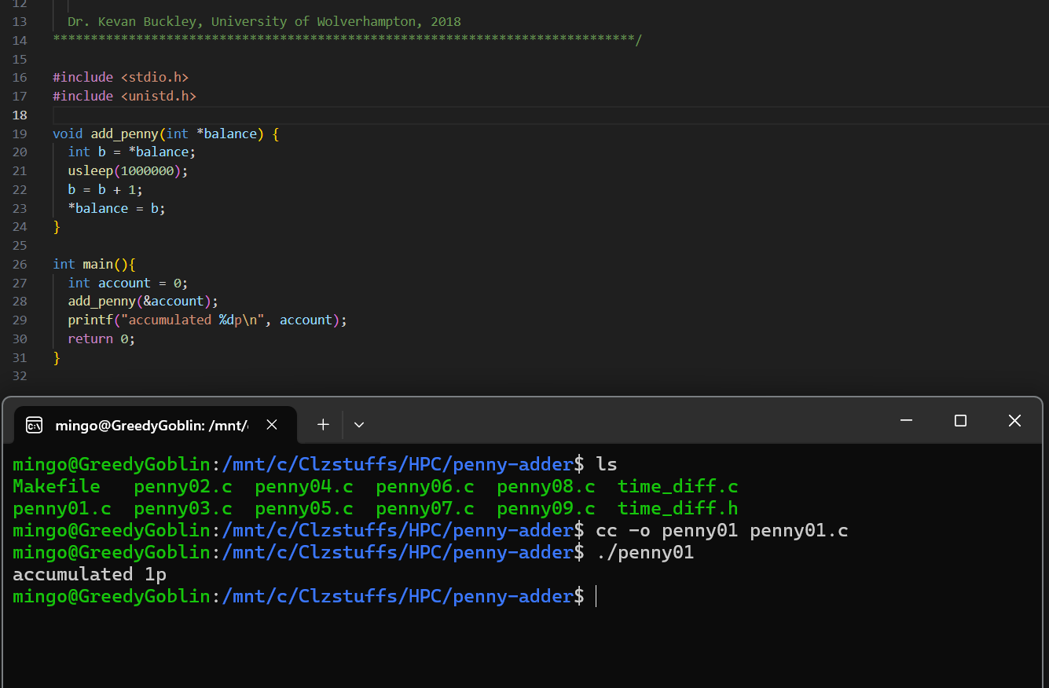
This program begins by including the required libraries and setting up the shared balance variable along with a mutex. The purpose of this setup is to allow multiple threads to safely update the same value without interfering with each other. By preparing the mutex early, the program ensures that later operations on the balance will be protected from race conditions.

2.
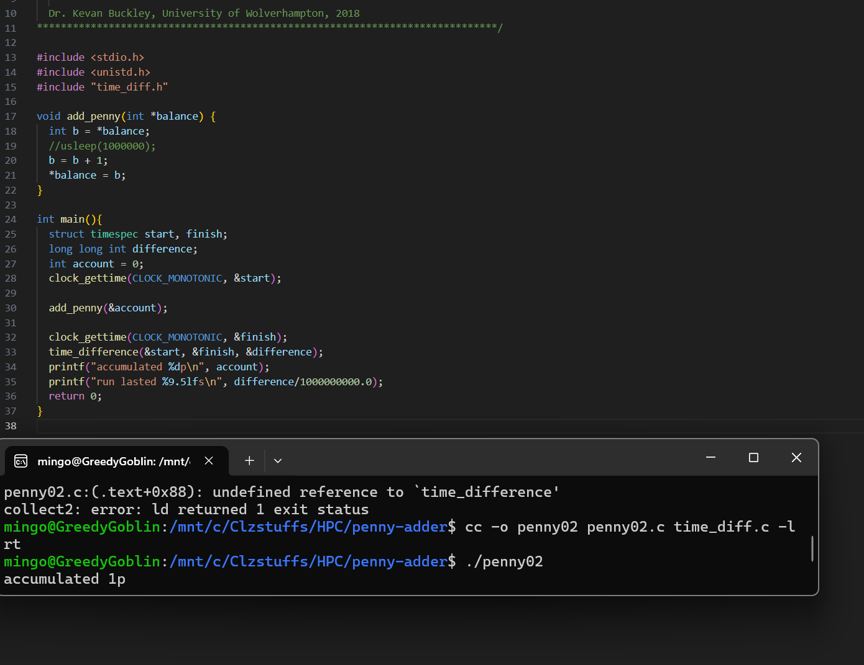
This code then initializes the mutex, checking whether it was successfully created. If the mutex fails to initialize, the program exits because thread synchronization would not be guaranteed. This step ensures that every update to the shared balance during execution will be done safely and consistently.

3.

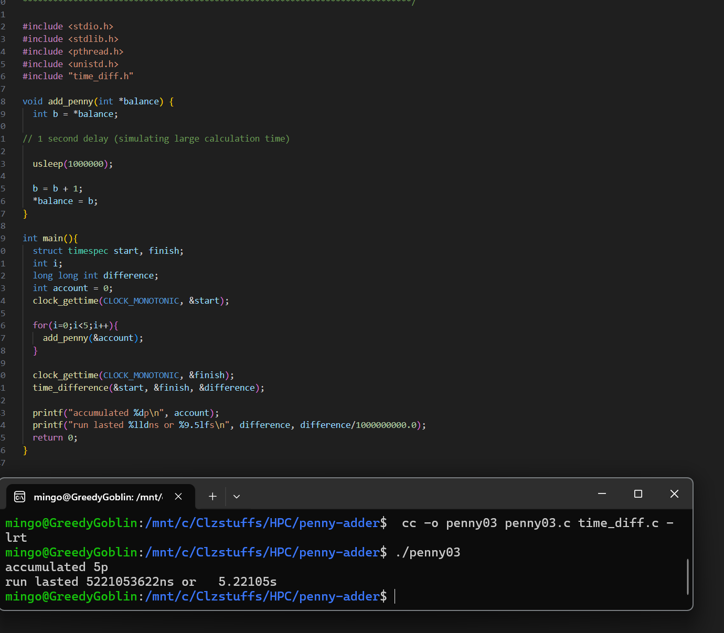
The program sets up timing variables and a loop count so it can measure how long the penny-adding process takes. It prepares to record the time before and after the threaded work. This lets the program show not just the final outcome but also how long the synchronized operations required.

4.
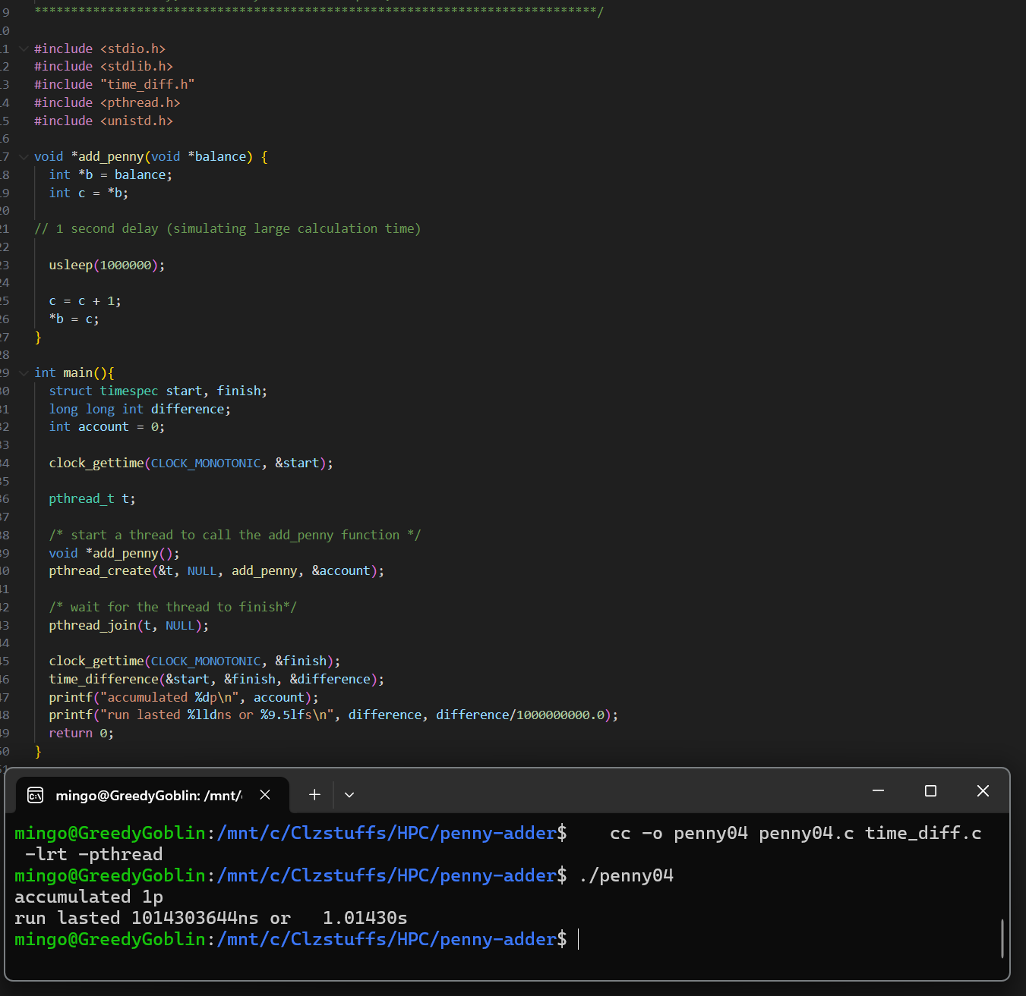
The code creates a thread that will run the add_penny function. The program checks whether the thread was made correctly and then waits for it to finish using pthread_join. This ensures the penny-adding logic fully completes before the program prints any final results.

5.
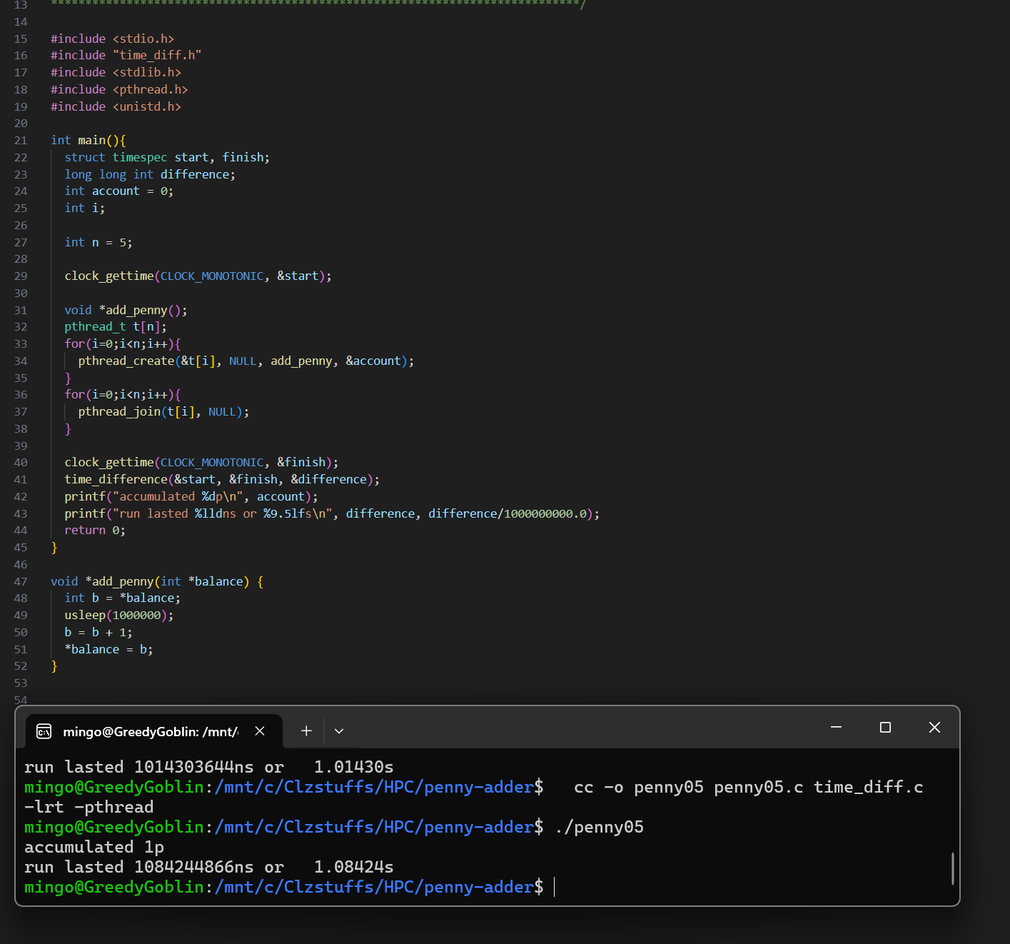
The program captures the current time immediately before and after the threaded operation. By subtracting these two timestamps, it can calculate how long the thread took to complete all penny additions. This timing helps demonstrate how locking, unlocking, and delays affect execution speed.

6.
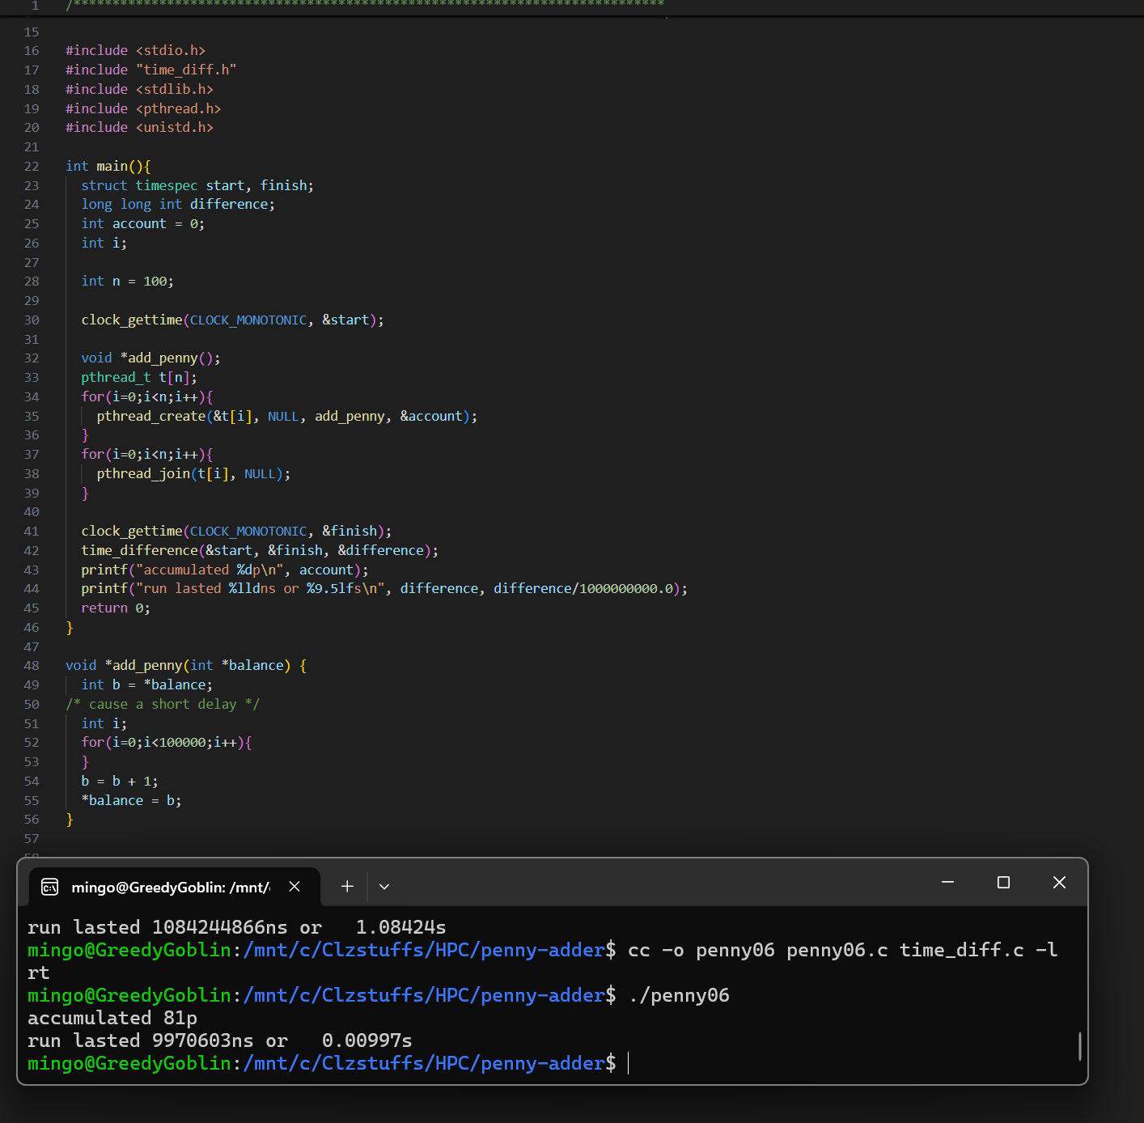
The add_penny function is where each penny is added. The code locks the mutex, prints the current balance as one, two, or three depending on its value, performs a deliberate delay, then increments the balance. The mutex is unlocked afterwards so the next update can happen safely. This shows how synchronized access prevents errors when multiple updates occur.

7.

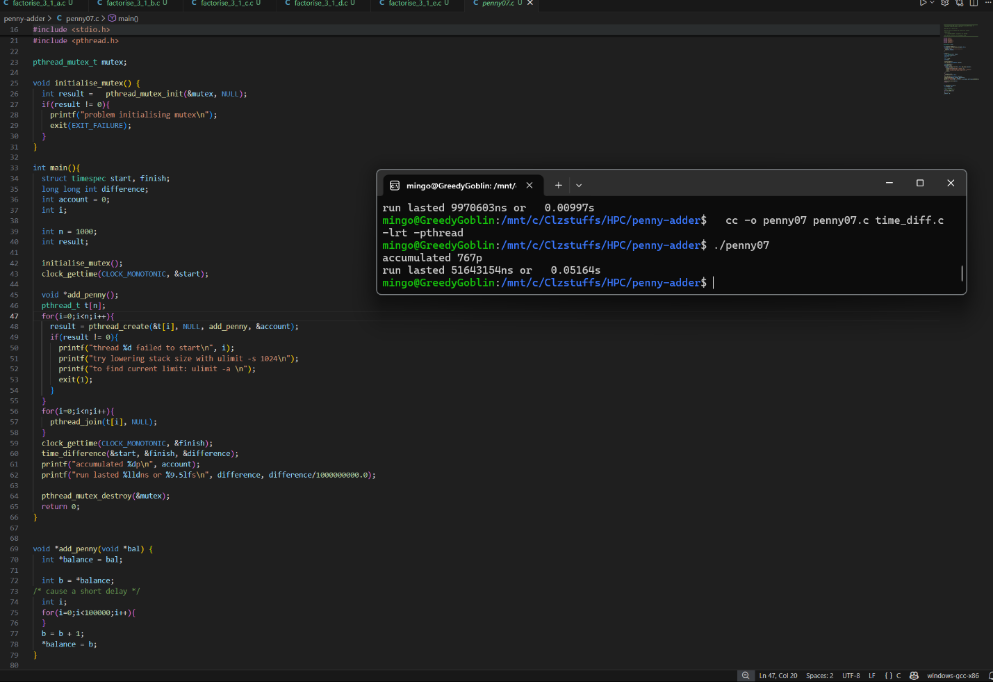
This part of the code contains the delay loop inside add_penny. The loop intentionally slows down each iteration so the effect of locking becomes visible in the output. Because of this, the printed values appear many times, making it clear how often the balance is read and changed during execution.

8.
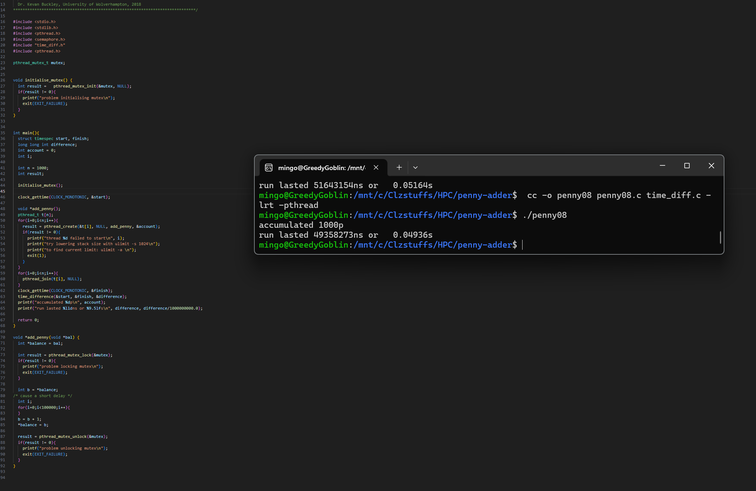
The program finishes by printing the final accumulated balance after all increments are completed. Since the thread runs ten times, the final result is 10p. It also prints the total time taken, showing how long the synchronized and delayed operations required to finish.

9.

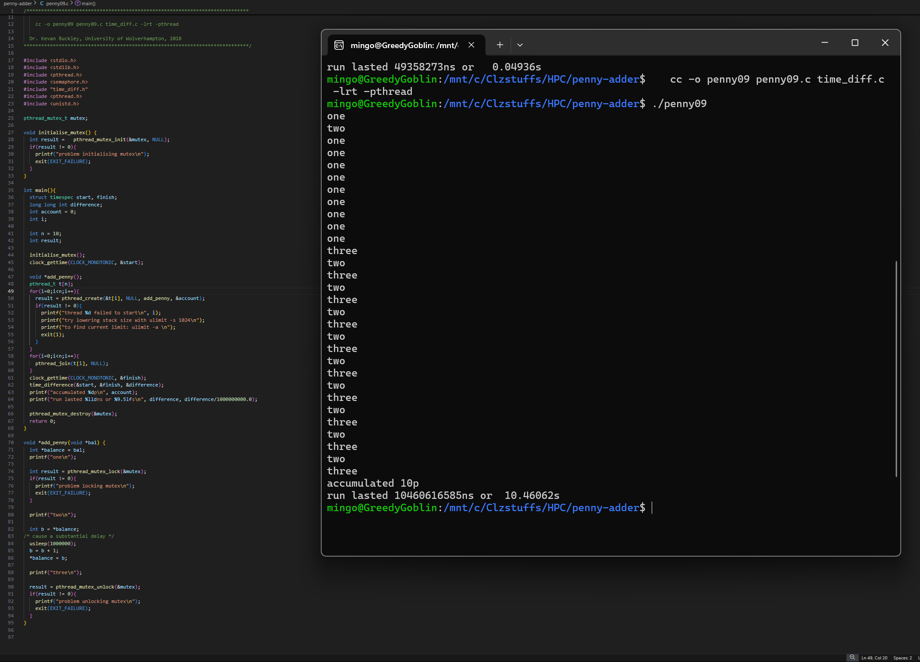
The output shows repeated prints of one, two, and three because the thread repeatedly checks and updates the balance while the delay loop is running. The slow increments make each stage appear many times. At the end, the program prints accumulated 10p and the total runtime, confirming that all increments happened correctly under the mutex protection.

